**VISVESVARAYA TECHNOLOGICAL UNIVERSITY**

Jnanasangama, Macche, Santibastwada Road, Belagavi-590018, Karnataka



**A**

**MINI PROJECT REPORT**

on

**Design of Sine & Cosine**

*Submitted in partial fulfillment of the requirement for the degree of*

**Bachelor of Engineering**

**in**

**Electronics & Communications Engineering**

*by*

**BHAVYASHREE SHETTY 1 DS14EC033**

**JYOTHSNA JOIS 1DS15EC053**

**MOHAMMED SARFRAZ SIDDIQUI 1DS15EC067**

Under the

guidance

of

**Prof. A. Rajagopal**

Assistant Professor, ECE Dept., DSCE, Bengaluru



**Department of Electronics & Communication Engineering**

**Dayananda Sagar College of Engineering**

(An Autonomous College affiliated to VTU Belgaum & accredited by NBA/NAAC)

Shavige Malleshwara Hills, Kumaraswamy Layout,

Banashankari, Bengaluru-560078, Karnataka

April 2018

**Mini project Report Declaration**

Certified that the UG Mini project entitled, “Design of Sine and Cosine functions” has been submitted as AAT for the subject Digital System design using Verilog with Subject code-EC661 is a bonafide work that is carried out by myself in partial fulfillment for the award of degree of Bachelor of Engineering in Electronics & Communication Engineering of the Visvesvaraya Technological University, Belagavi, Karnataka during the academic year 2017-18.I am solely responsible for all the contents that has have been presented in it.

Student sign

Student Name

USN: .

Date : / / Place : Bengaluru -78

**_______________________________________**

Mini project Guide

Name & Signature

Prof A.Rajagopal

Contents

1. Abstract 1

2. Introduction to the topic 1

3. Literature survey related to the topic 5

4. Scope & Objectives of the work 6

5. Motivation / Problem statement definition in the work 8

6. Problems Faced…………………………………………………………………………...8

7. Block diagram 9

8. Outcome / Results & Applications of work 10

9. Conclusions 16

10. References………………………………………………………………………………16

**ABSTRACT**

Sine and Cosine wave generators are widely used in different applications such as communications, control, biomedical electronics and, music synthesis. Sine and Cosine functions can be generated in various ways. This project explores two different techniques- Look Up Table(LUT) method, which uses ROM and CORDIC algorithm, which doesn’t require any memory. Comparison between these two methods is done in terms of speed, performance and hardware requirements. The sources were written in Verilog and implemented for a FPGA Spartan6 development board.

.

**INTRODUCTION**

Waveform generation is highly important in high speed wireless applications such as radar, telecommunication systems, instrumentation and many other fields. The commonly used solutions for the digital implementation of sine and cosine functions are table lookup method and polynomial expansions. Look Up Table(LUT) and CORDIC algorithm.

Sine and cosine wave generation through the use of LUTs is a well-known and widely preferred method due to its simplicity and swift programming under digital environment. The direct look-up table (DLUT), or sometimes referred to as numerically controlled oscillator (NCO) or direct digital frequency synthesis (DDFS), basically applies a phase to amplitude conversion strategy where pre-calculated coefficients of the sine/cosine wave are stored in a table and are accessed through the use of a phase accumulator. Numerous LUT methods with varying table compression ratios exist, and some have been explained in [2][3]. When no compression is applied, the table - or ROM when referring to digital structures - contains N even spaced coefficients for a complete period of the wave. The phase accumulator then can be used to regulate access to the N prestored angles through continuous iterations. The sequence resets once the iteration times the step exceeds N, effectively producing a wrap around. The absence of mathematical calculations gives a strong performance advantage to this method, where the signals purity is dependent on the table’s word length, the step size and the iteration rate. In order to improve area/resource consumption and distortion due to fractional addressing a number of strategies have been presented through the years were it, one such being the CORDIC method.

The CORDIC algorithm was first introduced by Jack E.Volder in the year 1959 for the computation of Trigonometric functions, Multiplication, Division, Data type conversion, Square Root and Logarithms. The algorithm provides an iterative method of performing vector rotations by arbitrary angles using only shift and add. It is a highly efficient, low-complexity and robust technique to compute the elementary functions. This trigonometric based approach relies on vector rotations for performing successive mapping between polar and rectangular coordinates (and vice versa). Although not LUT based strategy, the CORDIC still relies on predetermined phase, amplitude and frequency values for calculating points on sine wave. The key aspect of the CORDIC algorithm is that the result is achieved using only shift, additions/subtraction and table look-ups which map well into hardware and are ideal for FPGA implementation.

This project seeks to explore these two methods in detail and study various aspects in terms performance, size, computational complexity and speed of the aforementioned methods.

**LITERATURE REVIEW**

The design of sine and cosine waveform has been expensively researched and various techniques have been developed to optimize the performance, of both the LUT and CORDIC methods.

Ireneusz Janiszewski, Bernhard Hoppe, and Hermann Meuth [1] proposed a hybrid function generation for sine wave generation with high-precision NCOs, which combines traditional LUTs with the iterative procedures of the CORDIC algorithm. This paper results with SNR(dB)=92 with word length of 16 bit.

Gopal D. Ghiwala, Pinakin P. Thaker, GireejaD.Amin [2] proposed the simulation and synthesis of NCO. The Design and Realization of NCO includes Phase Accumulator and Look-Up Table. In this paper proposed system is design for output frequency 2.5MHz with 24bits word length.

Snehal Gaikwad, Kunal Dekate [3] proposed Direct Digital Synthesizer is done at clock frequency which is specified as normalize value relative to clock rate given. as it is dual Oscillator, hence it supports variable Width, Phase modulation and user defined frequency resolution with 5MHz output frequency.

Matt Bergeron and Alan N. Willson [4] proposed an architecture that used an angle rotation algorithm. This algorithm is used for phase to amplitude conversion. The architecture used phase accumulator of 32 bit and the clock frequency fclk is 1GHz which gives an output frequency of 400 MHz on Xilinx Virtex version 7 FPGA dissipate only 54.9mW.

Gaurav Gupta, Monika Kapoor [5] compared with traditional frequency synthesis technology, the designed DDS has the advantages of the tuning resolution can be made arbitrarily small to satisfy almost any design specification.The phase and the frequency of the waveform can be controlled in one sample period, making phase modulation feasible. There is no need to control the gain.

Priyankap. Chopda, Kavita S. Tated&Jayant J. Chopade[6] used the Numerically Controlled Oscillator (NCO) module to generate a sine wave at any desired frequency and its advantages over the conventional Pulse-Width Modulation (PWM) approach have also been covered. The use of the NCO is not limited to the generation of a sine wave. By using a proper filter with an appropriate cutoff frequency, any desired wave shape can be rendered to the resultant output.

**Scope and Objective**

The current research in the design of high speed VLSI architectures for real-time digital signal processing (DSP) algorithms has been directed by the advances in the VLSI technology, which have provided the designers with significant impetus for porting algorithm into architecture. Many of the algorithms used in DSP and matrix arithmetic require elementary functions such as trigonometric, inverse trigonometric, logarithm, exponential, multiplication, and division functions. The commonly used software solutions for the digital implementation of these functions are table lookup method and polynomial expansions, requiring number of multiplication and additions/subtractions. However, digit-by-digit methods exist for the evaluation of these elementary functions, which compute faster than software solutions.

The traditional implement method is lookup table and polynomial expansion method. Data accuracy of lookup table method depends on the size of the lookup table ROM. The size of the memory and the precision of phase accuracy are exponential relationship, which enlarges the resource consumption and reduces the processing speed of the system. However, under the request of high precision, it still consumes a lot of resources. Polynomial expansion method is a real-time computing method which needs multiplier resources and has certain restrictions on the complexity and speed of the hardware. It is too hard for the two methods to trade off speed, accuracy, and resource. Look up table(LUT) and Coordinate rotation digital compute algorithm (CORDIC) are proposed to solve the problem. CORDIC algorithm uses a basic algorithm to replace the complex algorithm. CORDIC algorithm is easy to hardware implementation. It does not require hardware multiplier and all operations are only shift accumulation, which meets the hardware requirements of modular and regularization algorithm requirements. LUTs is requires ROM memory but if memory is not the primary concern, it is best for the achieve high accuracy with less computational complexity.

**Problem Statement**

The main objective of this project is to design sine and cosine waves using Verilog and implement the same on FPGA boards. Two methods- Look Up Table(LUT) and CORDIC algorithm have been studied for the same purpose. The frequency, speed and hardware space required in each method is calculated.

**Problems Faced**

1. The understanding of the CORDIC algorithm was a little strenuous than expected and hence took a while to figure.

2. Initial execution was done on XILINX. But, due to the analog nature of the project, a different software was required.

3. ModelSim was needed in order to plot the sine output. Learning of the software was a requirement. The project required synthesis for the comparison of the two algorithms. Hence, switching between XILINX and Modelsim was challenging.

4. The LUT method for the generation of sine waves required values for different angles of sine, which required for the execution of another program to extract the value. It piled up the number of tasks required for execution.

5. The CORDIC method requires the usage of macro file sim.do and wave.do ,which was a little hard to understand due to the unfamiliarity with the concept. Time was taken to figure out the process to include these files into the Modelsim project in order to run it. All of this required understanding of unfamiliar topics.

6. The simulation of the CORDIC algorithm was quite challenging as it required several attempts in order to perfect the

procedure for the simulation as it required changing of the radix and the format of the plot to decimal and analog automatic

respectively.

7.) Challenges faced during DAC interface:

a. DAC interface took several failed attempts to figure out the actual working.

b. The challenge was to change the program to the required headers of a DAC.

This involved a bit of pre-reading and experimenting.

c. Different values had to be extracted and tried on the DAC in order to get a smooth

sine wave. This process was quite time consuming.

**BLOCK DIAGRAM**

**LUT method**

Look Up Table or Numerically Controlled Oscillator is constructed using ROM with samples of a sine wave saved in it (sine/cosine LUT) . Fig.1 represents the block diagram of a NCO system. The NCO produces continues signals at a certain frequency selective word (FSW) which determines the phase. Once set, this FSW determines the signal frequency to be produced. Phase accumulator output continuously produces proper binary words representing the instant phase to the look-up table function. The NCO will made up of phase accumulator and phase to amplitude converter. This phase to amplitude converter is nothing but Look up Table to convert phase to amplitude.

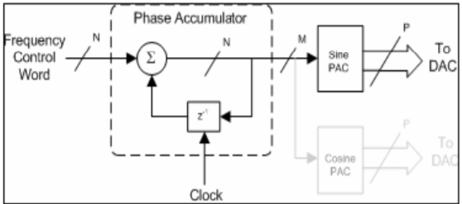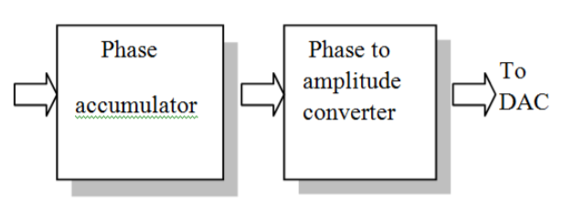

Fig1. Block Diagram of LUT sine & cosine wave generation

The frequency of the output signal for 8-bit system is determined by following equation

𝐹𝑜𝑢𝑡 = 𝑊 𝐹𝑐𝑙𝑘 /28

Where W is the FSW,

N=8 is the number of bits that the phase accumulator can handle.

Fclk is system clock

**CORDIC**

The co-ordinate rotation digital computer (CORDIC) reference design implements the CORDIC algorithm, which converts cartesian to polar coordinates and vice versa and also allows vectors to be rotated through a given angle. CORDIC is an iterative process, using a series of shifts and adds. Hence it is often a hardware efficient solution over using multiplications, division and square roots. CORDIC provides an iterative solution to performing vector rotations by arbitrary angles using only shifts and adds.

An external file that holds a picture, illustration, etc.
Object name is TSWJ2014-897381.001.jpg

Fig 2. Cordic vector rotation diagram

An input vector is rotated until it is on the x axis; the final x value is equal to the magnitude of the input vector. While rotating the vector, the total angle traversed is also recorded, which provides the phase of the input vector. Rotation mode performs polar to cartesian conversion. The input vector (x value equals magnitude and y value equals zero) is rotated by the specified angle. The final vector is the cartesian equivalent of the input polar values. Vector rotation mode rotates an input vector by a specified angle. The output gives the cartesian coordinates of the rotated vector. The final x and y values in rotation, vector rotation, and vectoring modes are scaled by the CORDIC processing gain. This processing gain varies with the number of iterations performed. It approaches 1.6476 as the number of iterations goes to infinity.

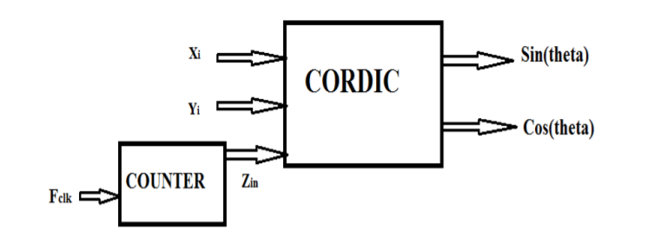

Fig. 3 CORDIC BLOCK DIAGRAM

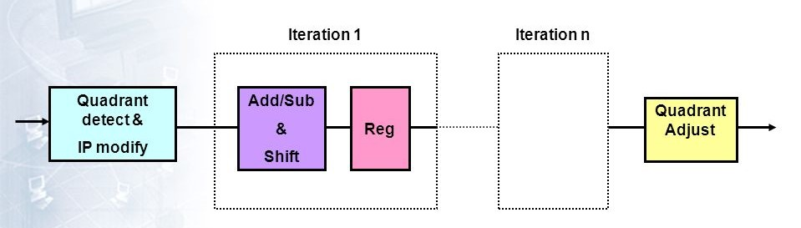

Fig.4 CORDIC ALGORITHM BLOCK DIGRAM

The CORDIC algorithm has parallel architecture which enables high performance.The algorithm can only deal with vector rotation of -90 to 90 degrees. The algorithm does not require any ROM memory. It requires additional logic (Quadrant block) to be able to deal with vectors in any of the four quadrants. Number of iterations determine the accuracy of the sine and cosine wave generated. Higher the iterations, better the accuracy but the speed is reduced.

**RESULT/OUTCOMES/APPLICATIONS**

**CORDIC METHOD RTL**

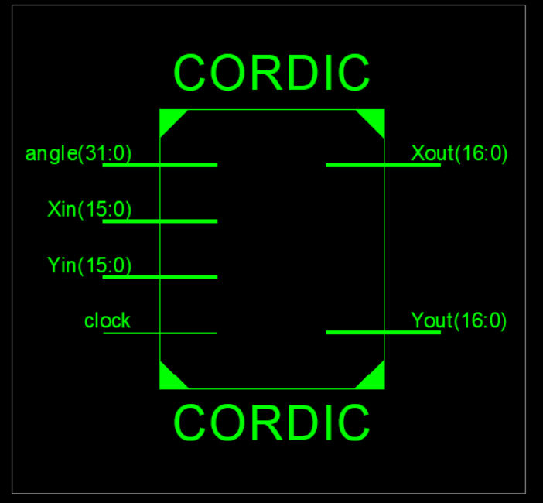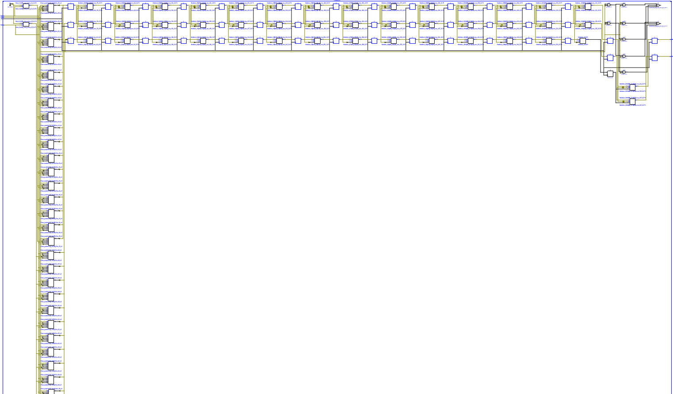

**CORDIC METHOD SIMULATION**

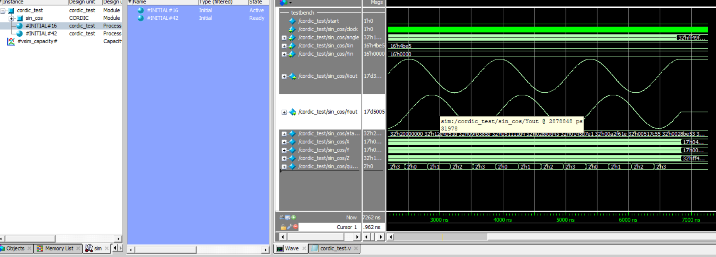

**CORDIC REPORT SUMMARY**

|  |  |  |  |
| --- | --- | --- | --- |
| **Slice Logic Utilization** | **Used** | **Available** | **Utilisation** |
| No. of Slice LUTS | 1044 | 5720 | 18% |
| No. of Slice Registers | 98 | 11440 | 8% |
| No. of Occupied Slices | 316 | 1430 | 22% |
| No. of LUT Flip Flop | 952 | 1052 | 90% |

**IO Utilization:**

Number of IOs: 99

Number of bonded IOBs: 99 out of 102 97%

**Timing Summary:**

Minimum period: 4.458ns (Maximum Frequency: 224.332MHz)

Maximum output required time after clock: 4.118ns

**Power Summary:**

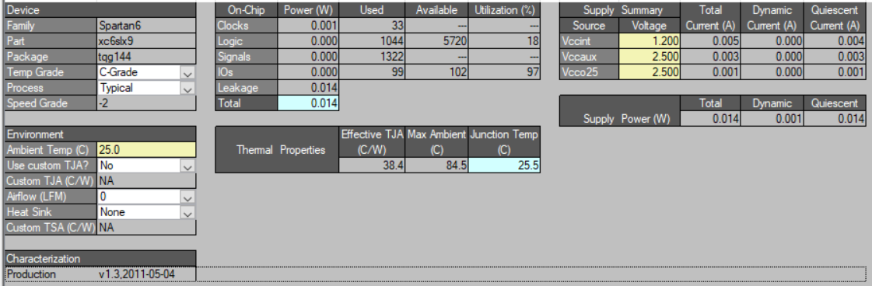

**LOOK UP TABLE METHOD RTL**

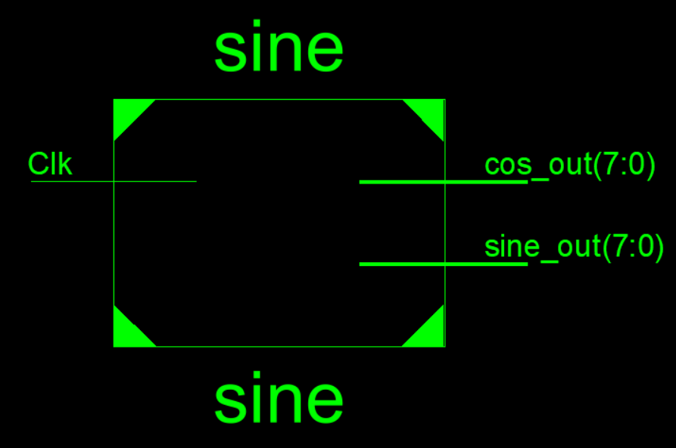

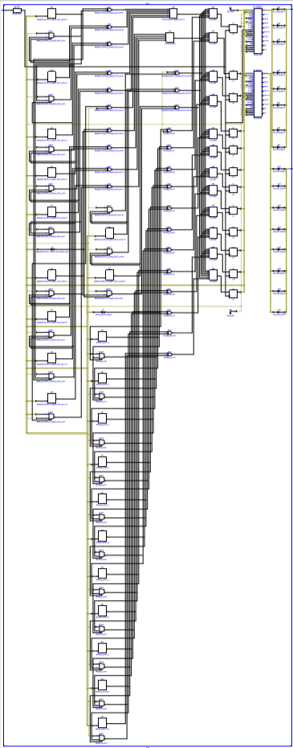

**LOOK UP TABLE SIMULATION**

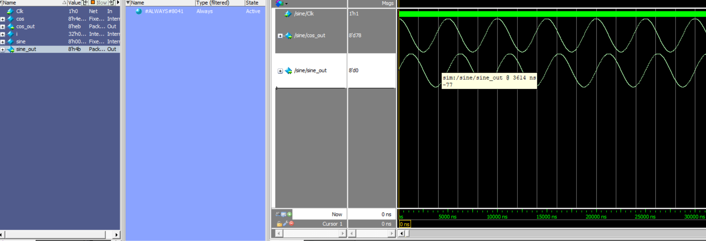

**LUT REPORT SUMMARY**

|  |  |  |  |
| --- | --- | --- | --- |
| **Slice Logic Utilization** | **Used** | **Available** | **Utilisation** |
| No. of Slice LUTS | 3677 | 5720 | 64% |
| No. of Slice Registers | 26 | 11440 | 1% |
| No. of Occupied Slices | 1281 | 1430 | 89% |
| No. of LUT Flip Flop | 4137 | 4163 | 99% |

**IO Utilization:**

Number of IOs: 17

Number of bonded IOBs: 17 out of 102 16%

**Timing Summary:**

Minimum period: 14.642ns (Maximum Frequency: 68.296MHz

Maximum output required time after clock: 6.838ns

**Power Summary:**

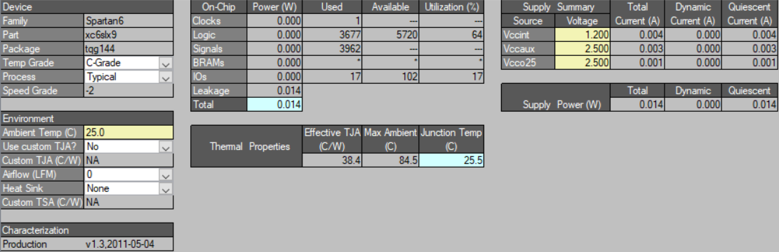

**APPLICATIONS**

1. Sine and cosine are used to separate a vector into its components in rectangular coordinates (x and y). This is important in mechanics, where vectors such as velocity and acceleration can be resolved into 2 perpendicular components.
2. Sine and cosine are used to convert polar coordinates into cartesian coordinates.
3. Sine and cosine are important to study simple harmonic motion.
4. Sine and cosine are used in electrical engineering to study AC circuits.
5. All trigonometric functions are associated with identifies and formulae that can be used to simplify complicated integrals into ones that we can integrate easily

**CONCLUSION**

The proposed worked focused on generating sine and cosine waveform using cordic algorithm and look up table method. The cordic method is found to be memory efficient but the accuracy depends on the number of iteration, hence the speed is reduced. Look up table method requires ROM memory and is more accurate with the increase in LUT values. The two methods were simulated in Modelsim Student Version and the implementation was carried on Spartan6 FPGA development board.

**References**

[1]. IreneuszJaniszewski, Bernhard Hoppe,and Hermann Meuth, “Numerically Controlled Oscillators with Hybrid Function Generators”, IEEE transactions on ultrasonics, ferroelectrics, and frequency control, vol. 49, no. 7, July.

[2]. Gopal D. Ghiwala, Pinakin P. Thaker, GireejaD.Amin, “Realization of FPGA based numerically Controlled Oscillator”, IOSR Journal of VLSI and Signal Processing (IOSR-JVSP) ISSN: 2319 – 4200, ISBN No.: 2319 – 4197 Volume 1, Issue 5, PP 07-11, (Jan. - Feb 2013).

[3]. SnehalGaikwad, KunalDekate, “Design and Implementation of Feasible Direct Digital Synthesizer to Eliminate Manual Tweaking”, IOSR Journal of VLSI and Signal Processing (IOSR-JVSP) Volume 2, Issue 4,, PP 53-56e-ISSN: 2319 – 4200, p-ISSN No. : 2319 – 4197, (May. – Jun. 2013).

[4]. M. Bergeron and A. N. Willson, "A 1-GHz direct digital frequency synthesizer in an FPGA," 2014 IEEE International Symposium on Circuits and Systems (ISCAS), Melbourne VIC,2014,pp.329-332.doi: 10.1109/ISCAS.2014.6865132

[5]. Gaurav Gupta, Monika Kapoor, “An Improved Analog Waveforms Generation Technique using Direct Digital Synthesizer”, International Journal of Computer Applications (0975 – 8887) Volume 78 – No.5, September 2013.

[6]. Priyankap. Chopda, Kavita S. Tated&Jayant J. Chopade, “Sine Wave Generation Using Numerically Controlled Oscillator Module”, BEST: International Journal of Management, Information Technology and Engineering (BEST: IJMITE) ISSN(P): 2348-0513; ISSN(E): 2454471X Vol. 3, Issue 7, Jul 2015, 35-40.

[7]. M. Madheswaran, and T. Menakadevi, “An Improved Direct Digital Synthesizer Using Hybrid Wave Pipelining and CORDIC algorithm for Software Defined Radio,” Circuits Systems And Signal Processing, vol. 32, no. 3, pp. 1219–1238, 2013.

[8]. <https://en.wikibooks.org/wiki/Digital_Circuits/CORDIC>

[9]. <https://github.com/benzea/nco>

[10]. <https://www.ncbi.nlm.nih.gov/pmc/articles/PMC4119700/>

[11]. <http://www.hdlexpress.com/Verilog/VT.html>